TASK 05 - Design the web pages for client creation and client meetings using HTML
and CSS

TASK 06 - Develop a web application and create various required components for
client management using Angular

TASK 09 - Run your Angular Project

Complete webApp to manage Clients and Meetings has been uploaded to - https://github.com/tukiasingh/manageClientsAndMeetings/tree/main/manageMeetings

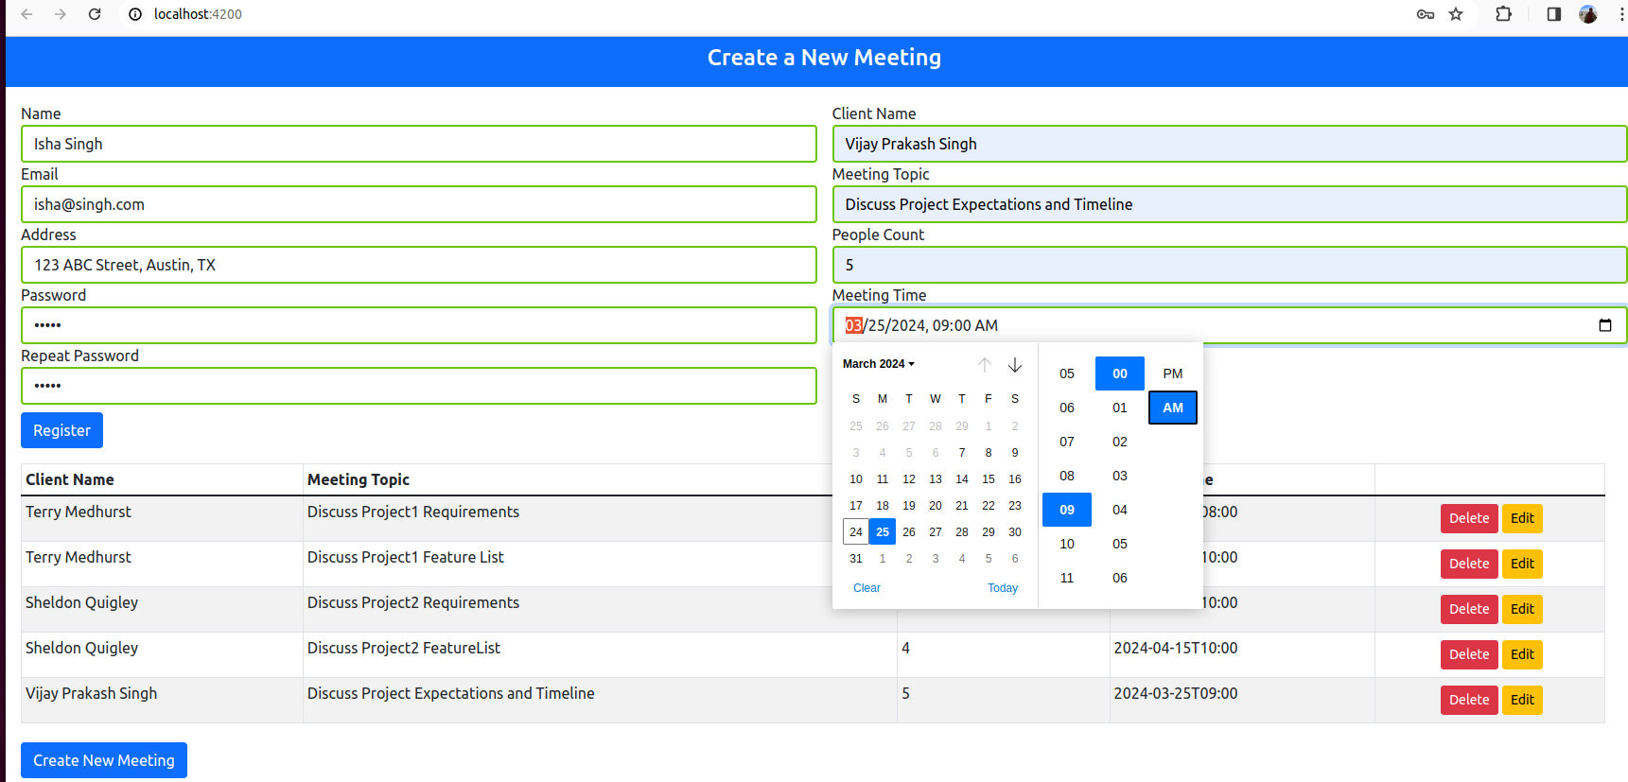

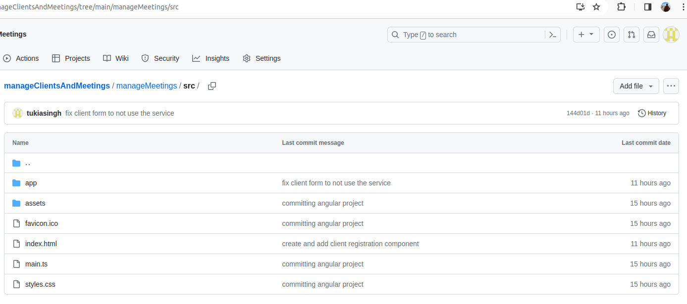
Notes:

1. Under src folder, index,html has been modified to include form and table selectors.

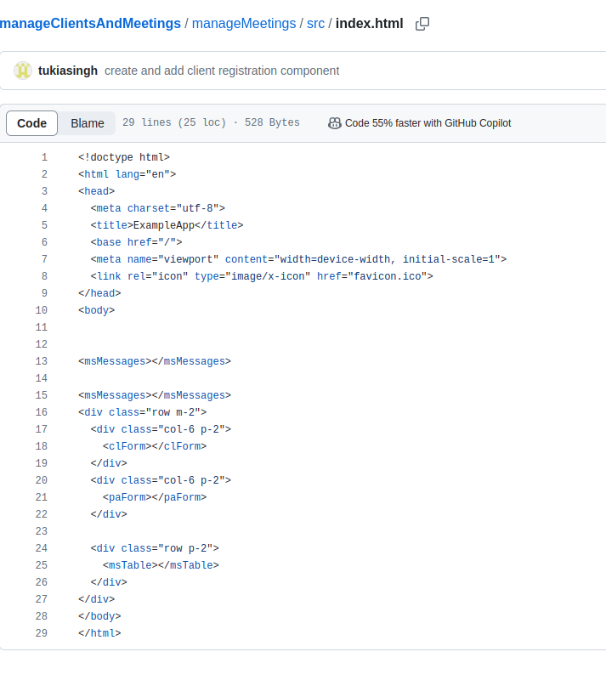
2, Under app folder, we have a core folder having HTML and components defined for Clients, Meetings and Tables.

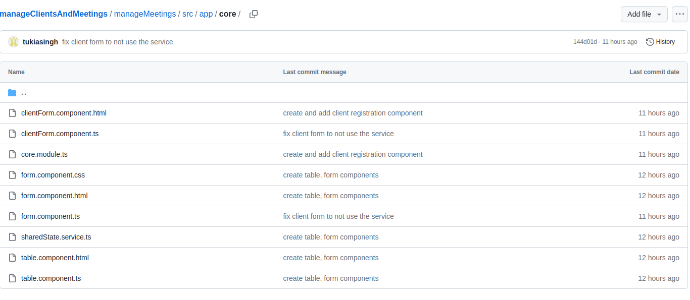

3. Under app folder, we have a folder named messages which provides common services to all components.

